Media Release

Record number of new cases of persecuted parliamentarians in the world

Belgrade, Serbia, Thursday, 17 October. For immediate release

At the 141st IPU Assembly in Belgrade, Serbia, IPU Member Parliaments condemned human rights violations against a record number of new cases of abused MPs. The IPU Committee on the Human Rights of Parliamentarians, the only international body with an exclusive remit to support MPs in danger, examined the cases of 305 parliamentarians in 10 countries whose human rights had been allegedly violated.

Full details of all the decisions are available on the IPU website.

Over half the cases are new complaints – mainly from Venezuela, Yemen, the Democratic Republic of the Congo, Sierra Leone and Libya. Most of the cases concern opposition MPs (83%) and a fifth are women MPs (21%).

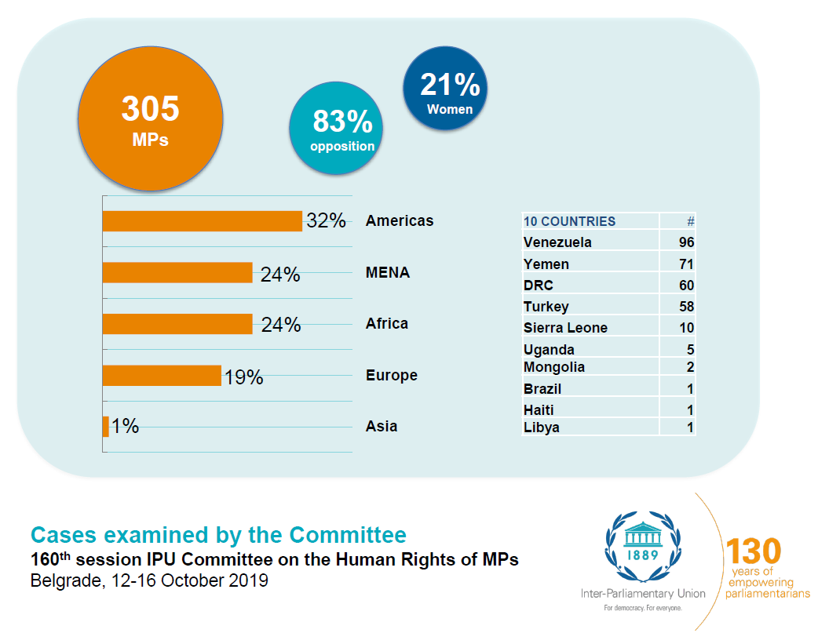

Venezuela

The number of cases of Venezuelan MPs examined by the Committee rose to 96 parliamentarians since its last session in April. There are 32 new cases, all from the coalition of Democratic Unity Roundtable Party (MUD) from the National Assembly of Venezuela.

The MUD coalition won a majority in the National Assembly following elections in 2015 and opposes the Government of Mr. Nicolas Maduro. The Government has not provided any funding to the National Assembly since August 2016.

The IPU is concerned about the widespread and systematic intimidation of MUD parliamentarians, which has reached new records, and urges the Government of Venezuela to stop these reprisals immediately.

The Committee met separately with MUD members from the National Assembly and members of the Bloque de la Patria parliamentary group that supports Mr. Nicolas Maduro to hear both sides.

The IPU calls on the Government of Venezuela to accept the IPU’s long-standing request for a fact-finding mission to address the human rights concerns and to help find a solution to the current political impasse.

Turkey

The Committee examined the cases of 57 current and former parliamentarians all from the opposition party, the People’s Democratic Party (HDP). Since December 2015, hundreds of trial proceedings on criminal and terrorism charges are going on against current and former HDP parliamentarians throughout Turkey.

Since 2018, 29 current and former parliamentarians have been sentenced to terms of imprisonment. Eight current and former parliamentarians are either in pretrial detention or serving prison sentences, including the former HDP co-chairs, Mr. Selahattin Demirtaş and Ms. Figen Yüksekdağ.

In June 2019, an IPU delegation of parliamentarians, including the IPU President Gabriela Cuevas Barron, was in Turkey on a fact-finding mission to evaluate the situation on the ground. The mission concluded that the authorities systematically present HDP parliamentarians as terrorists and their parliamentary work as terrorism although the HDP is a legally authorized political party in Turkey. The delegation also highlighted violations of the HDP parliamentarians’ right to free speech.

Yemen

The Committee evaluated the cases of 69 members of parliament from Yemen, all elected in the last parliamentary elections in 2003. The allegations range from attempted murder, abduction, arbitrary detention to property destruction.

Since the beginning of the political crisis in 2011 and the outbreak of the war in 2015, two different factions claim to embody the Yemeni Parliament: the parliament in Sana’a in the territories under the control of the Houthi militia and the parliamentarians who fled Sana’a and who belong to the internationally recognized Government of Mr. Abdrabbuh Mansur Hadi.

The cases examined by the Committee concern members of parliament who fled Sana’a and neighbouring governorates under the control of the Houthi militia. On 10 September 2019, the Sana’a-based House of Representatives reportedly lifted the parliamentary immunity of 35 of the 69 parliamentarians to allow criminal proceedings on treason charges to go ahead, which are punishable by death.

The IPU is monitoring the situation closely and calls for all parties to come together to find a solution to the current impasse.

Brazil

The Committee admitted the case of Mr. Jean Wyllys, a member of the Brazilian Chamber of Deputies since 2010. He is the first openly gay Brazilian member of Congress and a well-known supporter of the rights of the lesbian, gay, bisexual, transgender and intersex (LGBTI) community.

Mr. Wyllys has been harassed and subject to intimidation since he was elected to parliament because of his sexual orientation and political views. In January 2019, Mr. Wyllys decided to give up his parliamentary seat and go into exile because of repeated threats and the alleged failure of the Brazilian authorities to offer him adequate protection.

Mr. Wyllys’s decision to leave the country was also influenced by the assassination of Ms. Marielle Franco in March 2018, a local council member who was also a vocal supporter of LGBTI rights. Two ex-police officers were arrested in March 2019 over their alleged involvement in this murder.

The IPU Committee on the Human Rights of Parliamentarians has copies of threats and acts of intimidation made over the past three years as well as Mr. Wyllys’s requests for protection made to the police and the parliamentary authorities.

Libya

The Committee examined the case of a Libyan MP Ms. Seham Sergiwa, an independent member of the House of Representatives in Tobruk, and an outspoken critic of the current military offensive. To inform their deliberations, the IPU Committee met the first and second Deputy Speakers of the House of Representatives in Tobruk.

Ms. Sergiwa was abducted from her home in Benghazi in July 2019. Since the abduction, the IPU has pressed the Libyan authorities to take action. Without any sign of life three months later, there is growing concern about Ms Sergiwa’s fate.

The IPU urges the Libyan authorities to do everything they can to locate Ms Sergiwa and secure her immediate release.

Uganda

The Committee examined the human rights violations of five Ugandan MPs, four independent and one from the opposition party. The violations include torture, arbitrary detention, lack of fair trial and violations of freedom of expression.

One of the MPs, Mr. Robert Kyagulanyi Ssentamu, better known as Bobi Wine – a popular singer – has been a vocal critic of the Government and subject to a campaign of intimidation.

The IPU has asked for a fact-finding mission to the country to meet with the executive and judicial branches. Ms Rebecca Kadaga, the Speaker of the Ugandan Parliament, has expressed her supported for the mission.

The IPU is waiting for formal authorization from the Ugandan authorities to be able to travel to Uganda for the mission.

Sierra Leone and Democratic Republic of the Congo

The IPU Committee examined new complaints in Sierra Leone and the Democratic Republic of the Congo (DRC). The Committee declared the complaint regarding Sierra Leone inadmissible and decided to postpone a decision on the admissibility of the complaint in the DRC.

Background

The IPU is the global organization of parliaments. It was founded 130 years ago as the first multilateral political organization in the world, encouraging cooperation and dialogue between all nations. Today, the IPU comprises 179 national Member Parliaments and 12 regional parliamentary bodies. It promotes democracy and helps parliaments become stronger, younger, gender-balanced and more diverse. It also defends the human rights of parliamentarians through a dedicated committee made up of MPs from around the world. Twice a year, the IPU convenes over 1,500 parliamentary delegates and partners in a world assembly, bringing a parliamentary dimension to global governance, including the work of the United Nations and the implementation of the 2030 Agenda for Sustainable Development.

***

For more information about the IPU, contact Thomas Fitzsimons at e-mail: press@ipu.org or tf@ipu.org or tel: +41(0) 79 854 31 53

